

Deliverable #7

Client: ZOLERNA - Elissa Shorrock, CHRP

CREATED BY: Purple Team

* Vovc Alexandra
* Kanagiah Ashmitha
* Saeidi Amirreza
* Kanlic Vehab

Vanier College

Table of Contents

Executive Overview 4

Summary description of client 5

Revised summary narrative 6

Client’s comment 7

Discuss the various decisions……………………………………………………………………………………………………………………………..…………...8

Current Security Mesures 10

Future Work 11

User Interface Improvements………………………………………………………………………………….………………………12

Unimplemented user stories and functions……………………………………………………………………………………..13

Recommendations regarding future security measures…………………………………………………..………………14

Recommendations regarding unit and integration test……………………………………………………..…………….16

Appendix 1……………………………………………………………………………………………………………………………….……..17

Appendix 3…………………………………………………………………………………………………………..………………………….18

I, Ashmitha Kanagiah, 2062688, certify that I have contributed to this deliverable, A.K

I, Vehab Kanlic, 1979073, certify that I have contributed to this deliverable, V.K

I, Alexandra Vovc, 2038345, certify that I have contributed to this deliverable, A.V

I, Amirezza Saeidi, 2072457, certify that I have contributed to this deliverable, A.S

# Executive Overview

This document highlights the implementation of the work that has been done over the past weeks and discusses the future implementation of the website along with the clients’ comments as final feedback of our project. Also, it will include decisions that have been made regarding the design and implementation and the final business problem addressed of our team project.

Next, we discuss the current security measures and designs put in place to improve security. Furthermore, starting with appendix 1, indicates what has changed from the prototype to the implementation.

Next, appendix 2 includes the printed version of the user guide that’s written from the user point of view, meaning how everything works.

Appendix 3 shows every user story created in the past deliverables and pitched to the client and a print of its implementation. And finally, in the Citations tab includes the reference materials used in the implementation of this web application.

# Summary description of the client

Our client Elissa has a bachelor’s degree in Human Resources Management from the John Molson School of Business. At Zolerna, their mission is to deliver customized HR solutions to their customers in compliance with the latest employment laws and regulations. Zolerna services are delivered to the highest standards of human resource management, active communication, confidence, and understanding of your operations and unique business requirements.

Now that we have a better knowledge of our clients’ requirements for the web application that we will design for them, it is necessary to follow those points. We must be in accord with our tools and way of working as well as the clients’ needs and preferences. The client has her own designs and ideas wanted for how her interface wants to look like and it is in our duty to meet them and make sure it correlates to her visions. Zolerna already has a built-in website, and our goal is to implement new features to their already made web application as well as a mock-up of their website, not redesigning the entire interface.

# 

# Revised Summary Narrative

Our project didn't have drastic changes from the previous deliverables. The users of the application can log in by entering their log in information such as login name and password. They can book their appointment and choose Zolerna services or contact directly Zolerna. All this information will be stored in data base that can be later modified. Features such as Appointment cancellation, Appointment confirmation, Payment confirmation and Payment cancellation are implemented. In final web application there is also an admin, who has the privilege to edit any information on the web application, see all appointments and cancel them as needed.

# **Client’s comments**

Elissa Shorrock, CHRP

“I would like to thank purple team for their dedicated work on Zolerna website. This was for me personally a great experience to work with a group of great individuals that are part of Vanier College. Regarding the web application I would like to add that there is an option for a user and admin to manage the website. I am also happy that you were able to implement the feature packages as one of my future business models alongside appointments. Once again, I would like to thank you all for your hard work as a team and I am looking forward to work with you in the future

Thank you”.

Discuss the various decisions you made regarding both the design and implementation of the system, including both visual design and software design, including choice of programming environment.

We made various decisions regarding the design and the front end visual of our application as well as for the implementation of the application. It's normal for changes to come along the way and for things to alter from the original plan and that is okay. As long as we have all the features in by the end of it, that we respect the requirements needed as well as the web application runs effectively and smoothly, we don't have anything to worry about.

For the visual design of the application, we made many changes as we were implementing the application such as changes in the styling of the application. We based most of the visuals from the Figma representation that we made so we already had a goal of how the visuals will look like. Alterations happened during the implementation phase because every time we would run the code and see the application, there were stylings that were not pleasing to the eye. For example, there were modifications to the font of a text to better suit the background and the color scheme as well as color changes for texts to make it more appealing. We added borders and boxes to texts to make them more defined and stand out on the page. There were also changes in the way our logo looks from the original logo that is seen in our Figma prototype as well as we made changes to our menu bar at the top regarding its size and proportion. Since our Figma prototype, we added other features to our application such as an admin platform and for that part of the web application we were doing it as we were implementing. Since we already have an idea on how the format of our text is, the color scheme, the overall format and layout of our screens, we were able to estimate and implement the admin platform according to those standards.

For the software design of our application, we also made changes as we were doing the coding of our web application. We made changes regarding the HTML and CSS codes according to how the output looked like of our application every time we ran the code. We also made changes in the base code in PHP such as when implementing the admin platform. We had to improvise and didn't have much time to fully plan out ahead the implementation of the admin side since we decided it during the implementation phase in the last three weeks of the semester. Having to visualize an admin platform and all the features that come with it and implementing it was a challenging decision made as a team. We also made other small decisions in the software design for the features of the user end of our application such as how data is retrieved by a user, how the user can navigate through the web application and test out our features and how the data from the database is displayed in the admin side

# Description of current security measures

In our web application we have some security measures. For example, we have a hashed password in our database to protect the privacy of our users and admins. We also have the login and register to make sure not every random person buys our products or books a random appointment. We also have the option to change and modify the web page by being an admin and not a user.

Future Work

The future work of our web application is to implement the payment API. We always wanted to implement one but upon our client’s request we decided that we won't implement it for now. We want to do it for the future of our application to have a full functioning application. You will be able to actually purchase a package and simulate an actual checkout process. We also want to improve our styling and the overall visuals of our application. We want it to look more modern, more colorful, and sharper and cleaner. With more time, we can edit the views of our web and make it look more appealing and pleasing to the eyes. We want to try to make it look more professional rather than simple and basic. We also want to upgrade the admin side of our application. We want the data retrieval from our databases to be displayed in a more professional and styled manner.

User Interface Improvements

We did an entire front-end of our web application before starting the back end of it. We used HTML and CSS to create a mock-up of our application to have an overall visualization of the navigation and the flow of our website. This will help in putting this into work to collaborate in making the back end. Since we are using PHP to do the application, HTML and CSS will be used for the styling and for the views of our interfaces and the fact that we did an entire mock-up of our web application beforehand in HTML and CSS is helpful in many ways. We can use code from our mock-up and incorporate it in our web application to save time.

We added a “Cart” feature, which we never planned to do before. We didn't have it in our User Map as it was a decision that was made afterwards. The Cart feature simply displays the pricing of our HR package and redirects to a checkout page. There is no Payment API. It is simply displaying a checkout view for the user. We decided to implement the Cart view to emphasize our web application considering the fact that it is a simple web application wanted by our client. Our client approved of this addition.

Unimplemented user stories and functions

For the user end, there are no unimplemented features for our web application. We have already reviewed and finalized all the features and aspects that we are going to put in our application through the deliverables and we all stuck to it. We had the necessary time to implement all the features desired. Everything corresponds to our latest version of our user stories, and it is pretty much accurate to it.

We added an admin end to our application and for that we also had all the features that we wanted to implement and function. Even if the admin wasn't mentioned in our user stories at first, we were still able to get a grip about it by inspiring ourselves with the previous versions of user stories that we have made.

Recommendations regarding future security measures to be taken

* Validation of user registration

When registering information to create a new user, having constraints such as the email to be in the proper format ([example@email.com](mailto:example@email.com)), having a proper format for phone numbers (xxx-xxx-xxxx) can be used to increase security measures. It provides accuracy and the user entering their credentials feels like they are browsing a trustworthy web application. Also having requirements for password inputs such as having a mix of letters, numbers, special characters, and capital letters can make the user feel secure. These are aspects that can be used to validate user registration. Unnecessary and random inputs are avoided when having such constraints as well as there won't be repetitive users created which avoids confusion in the database.

* Validation of login input

When logging in, having a database to validate the user input and make sure the credentials given by the user is correct and accurate. Having the application verify if the input matches the saved credentials from the database is effective and secure.

* Error messages

Display error messages when inputs don't fit the standards and that violates the constraints that have been put as well as blocking the user to go to the next page or to execute a specific task because the input is not fit to the standard.

* 2-Factor authentication

Enabling 2FA increases security measures in our web application. It makes sure that the user logging in is actually themself and not a third-party person. Having such security is necessary in our modern world because identity thefts and hacking are pretty common.

* Blocking the user after multiple attempts.

Another security measure that can be taken is that the application blocks the user if they failed to enter their credentials successfully after a fixed number of attempts. This can show that the person trying to log in is probably not themself or it can be a hacker. This provides security because it protects our individual’s account. Resetting passwords through their email or having to unblock their account by validating the user by email or any other resource can be a way to recover their account and make sure that the user is aware that there were several attempts of logging in of their account.

Recommendations regarding unit and integration test strategies to be used

First of all, we need to identify the aspects of unit and integration tests. We need to know the difference between both according to our web application to decide which comes first and how it will perform. Make sure that integration tests and unit tests are separated and that they are not being executed together. Picking the right tools and planning the tests is also essential. The end goal is to retrieve defects and problems from our software that produces a poor execution and flow of the application and to fix those defects to make the application effective. As well as it fixes any security issues that can come across. It is also needed to make sure the connection between the application and the database is secure, smooth and running.

# Appendix 1

The UI did not go through a lot of changes during implementation. The followed closely the prototype and the end result is very similar.

The reason why we did not implement many changes is that the client was satisfied with prototype interface. The implemented user interface is simple and easy-to-understand. Everything can be found at the top navigation panel and the interface is very intuitive.



Appendix 3

User Can Login and/or Register depending on if they already logged in or registered:

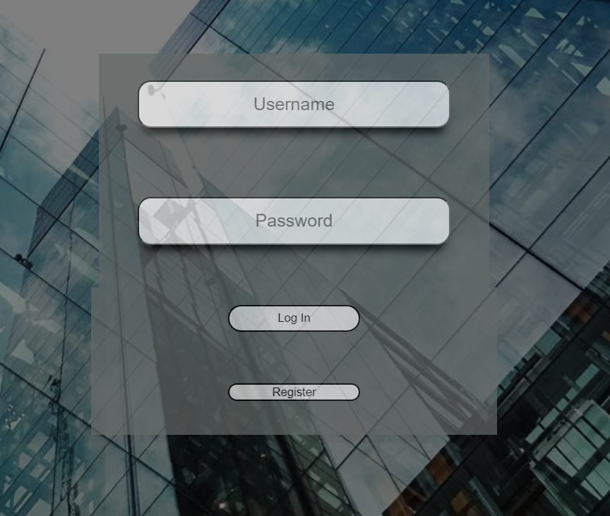

The user can take an appointment or cancel an appointment with a HR agent:

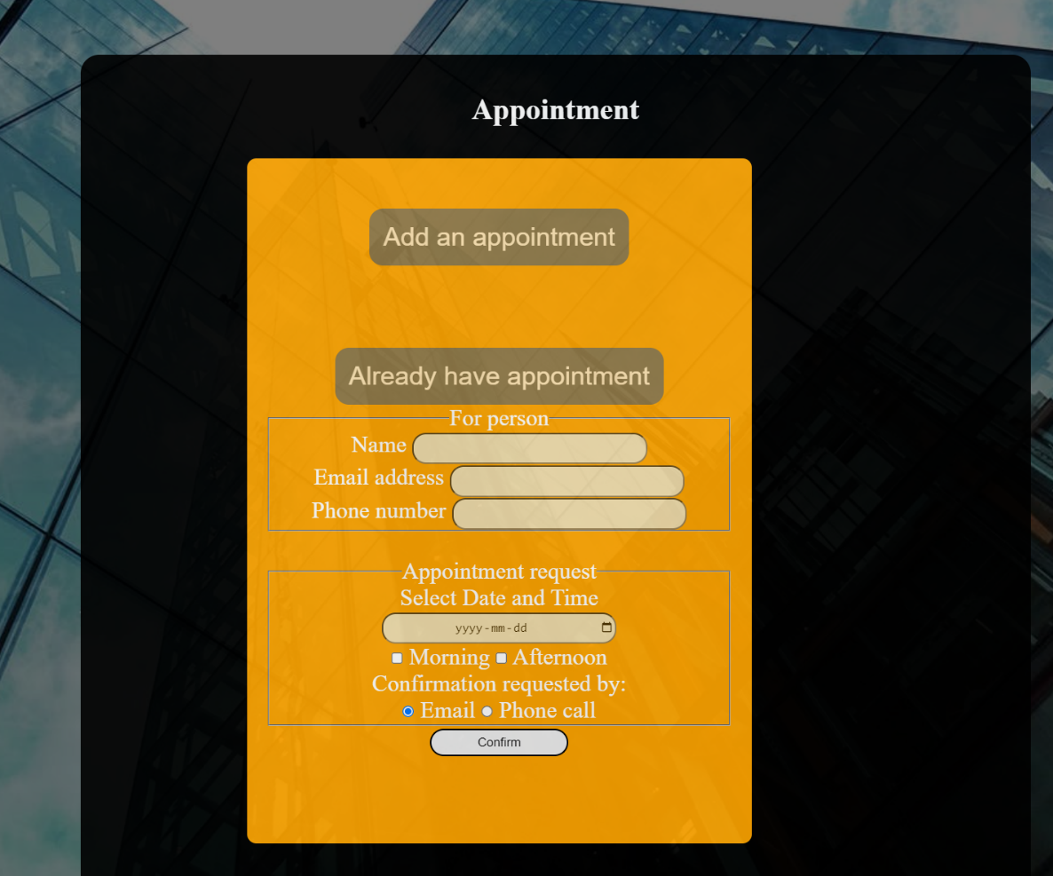

The user can choose what package they want by clicking on one of the options below:

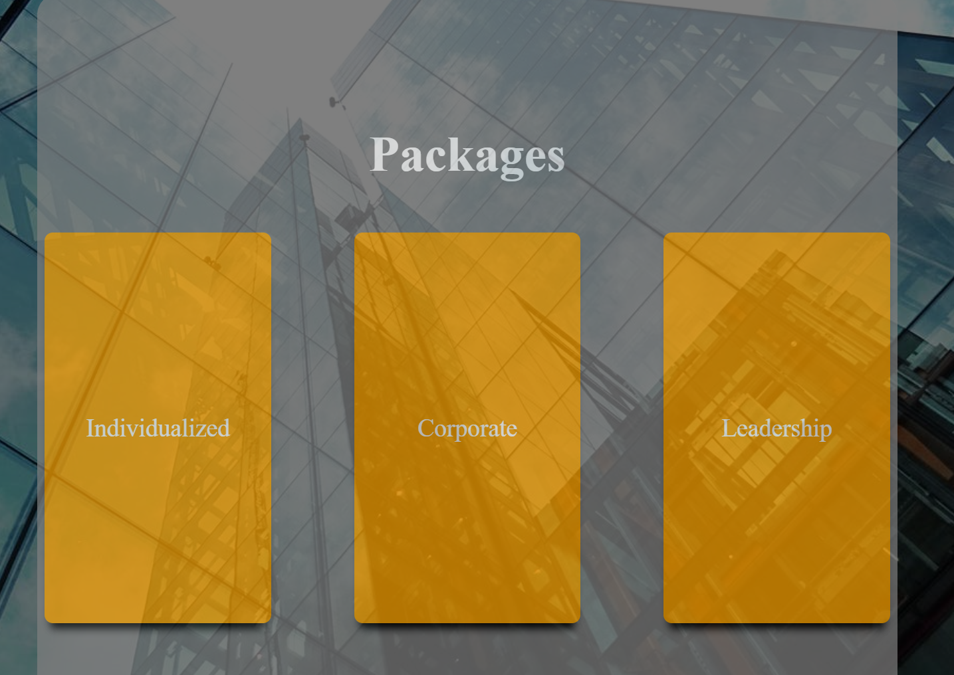

The user can buy one of the packages by clicking on the ‘Purchase’ button

